**Leader Overview**



**Volume Overview**

**How do I fulfill God’s mission?**

*Christianity is so much more than only another religion. It’s not just another collection of rules and regulations. It’s a real relationship with Jesus Christ. When we give our heart to Jesus, He becomes our Savior and our Lord. Life is not only full of responsibilities, bills, and work, but it can also be full of eternal purpose.*

*As we grow closer to God, He begins to reveal His true purpose and plans for our life. We begin to discover the personal mission and assignment He has designed for each of us. While we may have different gifts, talents, and abilities, each of us is called to the same mission of helping to transform the world with God’s love and power. God calls us to personally share our faith, to help lead others toward a deeper walk with Christ, and to help others fulfill their individual mission. As we lean into God and allow Him to make a difference in our life, He will in turn use us to make a difference in the life of others.*

**Session Overview**

**I Send Others**

*God appoints missionaries for the special task of traveling throughout the world to tell people about Jesus, but it takes the whole Church to send them. In the New Testament, Paul and Barnabas were set aside for this important task, and they were supported through the prayers and finances of the church in Antioch. Kids will learn that we can partner with God and His mission by praying and giving to missionaries too.*

**Bible Lesson**

Barnabas and Paul Sent to the World

[Acts 13:2–12](https://ref.ly/logosref/Bible.Ac13.2-12); [2 Corinthians 8:1–5](https://ref.ly/logosref/Bible.2Co8.1-5)

**Faith Fact**

I will help others go.

**Faith Verse**

[Matthew 28:19](https://ref.ly/logosref/Bible.Mt28.19) (NLT)

“Therefore, go and make disciples of all the nations, baptizing them in the name of the Father and the Son and the Holy Spirit.”

**Preparing for the Session**

**Leader Preparation Time: 20–25 Minutes**

|  |
| --- |
| ***You Will Need***  ***Large Group***   * *Bible* * *Worship songs (Song suggestions: “Tell His Story” lyric video by Yancy; “Real Love” lyric video by Hillsong Young & Free; “For the One” by Brian and Jenn Johnson; “Build My Life” by Passion)* * *For groups not using a phone or tablet only, add:*   *• Projector or TV*  *• Laptop*  *•* ***Countdown60 Video****–60 seconds*  *•* ***Faith Fact Slide***  *•* ***Faith Verse Video*** *or* ***Slide***  *•* ***Bible Lesson Video***  *•* ***Teaching Point Slides 1–3***  *• Two small, matching balls, one for each team*  *• Smartphone stopwatch*  *• Slingshot and something to launch (Ping Pong® ball, small rock, nut in its shell, etc.)*  ***Small Group***   * *Paper or plastic cups, six per group* * *Rubber bands, 2–3 inches in size, one per small group* * *String or yarn, 24 inches long, one piece per kid* * *Scissors* * ***Countdown60 Video****–60 seconds* * *Cups, two per group* * ***Small Group Faith Verse Review Page****, two copies per group* * *Scissors* * ***Small Group Activity Page****, one per kid* * *Crayons or markers*   *To access session content and videos from a computer, visit:* [*BibleEngagementProject.com/downloads*](https://bibleengagementproject.com/downloads) |
| ***Getting Ready***  ***Large Group***   * *Download videos and slides if needed.* * *Select worship song(s) and have them ready to play.* * *Read the Bible Lesson Scripture to prepare for Teaching Time.*   ***Small Group***   * *Cut pieces of string about two feet in length, one piece per kid.* * *Optional: Watch this video to see how the activity works.* [*https://www.youtube.com/watch?v=jc_QNz_NbkM*](https://www.youtube.com/watch?v=jc_QNz_NbkM) * *Print copies of the* ***Small Group Faith Verse Review Page****, two per group.* * *Cut apart each set and place each set of slips in a cup.* * *Print copies of the* ***Small Group Activity Page****, one per kid.*   *First time leading* Learn *for Kids? Check out the* [*Facilitator Guide*](https://0b769b0ed3569ef9d18b-f88d8272f61086866d50d048b43ef630.ssl.cf2.rackcdn.com/sites/biblengagementproject/Listen_Facilitator_Guide.pdf)*.* |

**Large Group**

**30 Minutes**

*See what’s needed at the beginning of the session.*

**Introduction**

Welcome, everyone! We’ve been finding out how we can fulfill God’s mission to help people know Him better and get closer to Him. He wants all of us to be part of this mission. Today we’ll discover how to help others do what God has called them to do.

Okay, I have a question for you. Who is your favorite sidekick or buddy character who helps the hero in a book or movie? (*Allow responses.*)

Those are some pretty awesome characters! Sometimes, the hero’s sidekick gets to be the one who saves the day in some unique way—even if they aren’t out in front. In today’s Bible story, we’ll hear about some very important helpers. They made it possible for some missionaries to take the gospel to people who had never heard of Jesus. Let’s get started!

**Faith Fact**

Here comes a special phrase to remember today! Our Faith Fact is: **I will help others go.**

• *Show the* ***Faith Fact Slide.***



Since we’re talking about going, let’s stand up and jog in place as we say the Faith Fact together. **I will help others go.** Keep jogging. Turn and say it to one of your neighbors. **I will help others go.** One more time. **I will help others go.** Great job! Have a seat.

**Game**

**Fast Pass**

|  |
| --- |
| ***You Will Need***   * *Two small, matching balls, one for each team* * *Smartphone stopwatch*   *No prep is needed for this activity.* |

Let’s play a game called Fast Pass. We’ll form two teams.

• *Optional: Kids can stay in their seats to play this game if group size or room requires it.*

Each team will form a line. I’m going to give a ball to the first person in each line. You’re going to work together as a team to pass the ball down the line, all the way to the last kid. When the last kid gets the ball, that kid will run and bring it to me. Let’s get started!

• *Optional: Time how long it takes to pass the ball. Play again to beat the time.*

Wow, you did a great job playing that game! Was it easy to work together on this game? *(Group response)* In games like this, we sometimes focus on that last team member who ran the ball to me. The same thing can happen when people do big things for God like be a missionary. It can be easy to think that the missionary is the most important one on the team. But there is a whole group of people helping the missionary fulfill God’s mission.

**Worship**

I’m so thankful God gives us people to support us as we obey God’s call! Let’s thank Him for that as we worship. Who is ready to worship God by singing today? *(Group response)* Let’s do it!

• *Lead the kids in singing one or two praise songs. See suggestions at the beginning of the session.*

**Bible Lesson**

I really love worshipping God with all of you! Now it’s time to discover something new in God’s Word. Do you ever wonder about your part in fulfilling God’s mission? *(Group response)* That’s a question a lot of people ask. Today, we’re going to find out how some people in the Bible helped fulfill God’s mission by supporting others. Their part might seem like it was in the background, but it’s super important. Let’s pray and ask God to open our heart and mind to His Word!

**Prayer**

|  |
| --- |
| *Dear God, thank You for Your Word. Please help us discover how we can fulfill Your mission by helping others go. Amen.* |

**Video Intro**

Just before we read the Bible story, let’s watch this video.

• *Play* ***Bible Lesson Video****.*

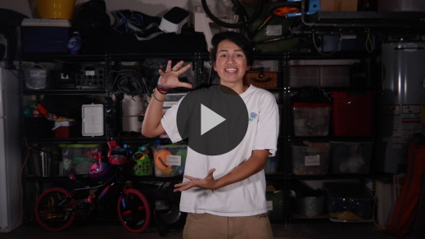

**Bible Story**

**Barnabas and Paul Sent to the World**

That video really got me interested in finding out more about our Bible story! We talked a little earlier about our favorite sidekick and buddy characters. They help the heroes a lot, even when they are in the background. Imagine what it would be like to help your favorite superhero in their next movie. That would be pretty awesome, right? *(Group response)*

Sometimes we think fulfilling God’s mission means preaching to hundreds of people like a pastor or moving to another country like a missionary. Maybe God will call you to be a pastor or missionary, and that’s amazing! But that’s not what God calls *everyone* to do. Let’s look in God’s Word and figure out exactly what that means. Grab your Bible or pull up a Bible app on your device. Turn to [Acts 13:2–12](https://ref.ly/logosref/Bible.Ac13.2-12) first. Then we’ll turn to [2 Corinthians 8:1–5](https://ref.ly/logosref/Bible.2Co8.1-5).

• *Read the passages aloud to the group.*

• *In order to keep Large Group time moving along, we don’t recommend having the kids read.*

• *Optional: Remind the kids to mark this place with their Bible Bookmark, so they can read it on their own at home.*

**Teaching Time**

|  |
| --- |
| ***You Will Need***   * *Slingshot and something to launch (Ping Pong® ball, small rock, nut in its shell, etc.)*   *No prep is needed for this activity.* |

We just read in the [Acts 13:2–12](https://ref.ly/logosref/Bible.Ac13.2-12) passage about Barnabas and Paul becoming missionaries. Remember, Paul was called Saul sometimes, like in the Bible verses we read. Don’t get confused! Paul and Saul are the same person. Anyway, he and Barnabas got to do some really amazing things for God. But there were other people who made it possible for them to go. The people supporting them weren’t with Paul and Barnabas when the cool stuff happened. But Paul thanked the helpers anyway. He knew they were part of the missionary work through their generosity and prayer support.

We can also help others obey God’s call and go. Helpers are important. What an amazing job to send other people around the world to share the gospel! Our Faith Fact reminds us of that. Let’s say it together. **I will help others go**. Shout it out this time. **I will help others go**.

There are three things to remember about helping others and fulfilling God’s mission together.

**1. God sends people around the world.**

• *Show the* ***Teaching Point 1 Slide.***

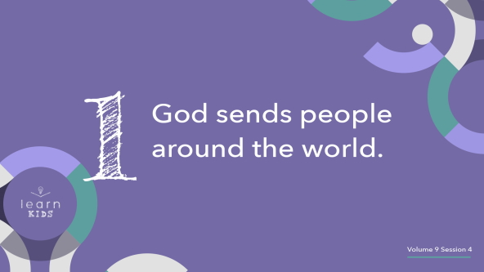

God wants everyone in the entire world to know that He loves them. No matter who they are, no matter where they live, no matter what they’ve done—God wants them to know Jesus died on the Cross for them. Jesus has already paid for their sins so they can live forever with Him. Everyone in God’s family, the Church, is part of His mission to tell the good news to the whole world. But our jobs don’t all look the same. God calls different people to different roles. To help us think about this, I brought something with me today.

• *Hold up the slingshot.*

Now, it’s really easy to think the most important part of this slingshot is the ammo—whatever gets shot out of it. I mean, that’s the thing that hits the target, right? *(Group response)* But if you look closer, the slingshot is made of three important pieces: the handle, the elastic band, and the ammo that gets shot out of it. We’re going to talk about all three, because each one is super important if you want to hit the target!

The ammo shot out of the slingshot is very important, of course. That’s what hits the target. Missionaries like Paul and Barnabas are like the ammo. They are the ones who go around the world and tell people about God’s love for them.

Did you know there are millions of people in the world who have never even heard of Jesus before? *(Group response)* Missionaries travel near and far so others can hear about Jesus and be saved. Being sent out is their special assignment from God. Maybe God will call some of you to go and be missionaries! Wouldn’t that be awesome? But some of us will have a different job. Let’s keep going and find out more.

**2. We support those God sends by praying.**

• *Show the* ***Teaching Point 2 Slide.***

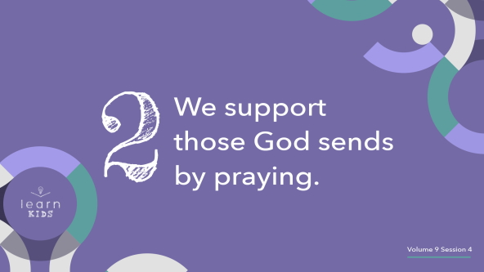

Let’s look at the slingshot again. It’s made of two main pieces: the elastic band and the handle. These remind me of the two big ways that we can help missionaries.

First of all, looking at the handle makes me think of how important prayer is. Let me show you what I mean. Without the handle, you just have some elastic and an object to launch. You might be able to shoot it a short distance if you hold it just right. But you can send it way farther if you tie the elastic to the handle.

Sometimes we might think our prayers don’t matter all that much, but the Bible says just the opposite. The prayers of God’s people make a huge difference! One way we know that is because Jesus taught us to pray for God’s will to happen. And we know God’s will is that more people would know and believe in Him. That’s why we pray for missionaries—so that God’s mission can be fulfilled!

Our prayers are a solid foundation for a missionary, just like the handle of the slingshot. Prayer supports them, encourages them, and does miracles we can’t always see. We pray in faith because we believe God will make a big difference in a person’s life through the work of missionaries. God blesses their special assignment and reinforces their work through our prayers.

**3. We support those God sends by giving.**

• *Show the* ***Teaching Point 3 Slide.***

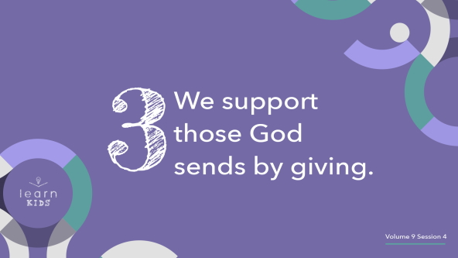

If the missionary is the object being launched and our prayer is the handle, what do you think the elastic band represents? *(Allow responses.)* Let’s remember what Paul said in the [2 Corinthians 8:1–5](https://ref.ly/logosref/Bible.2Co8.1-5) passage we read earlier. Even though these church people were very poor, they gave money to help other Christians. Paul said they were generous and gave even more than he hoped for. Giving money is another big way we can help missionaries.

Let’s think about the elastic band as our giving. The money we give helps missionaries do the work God has called them to do. It helps to send them wherever God has told them to go, just like the elastic band sends the ammo wherever we point it.

Now, you might be wondering, *“Why should I give my money to help a missionary?”* That’s a great question! Let’s talk about it. Missionaries usually don’t have normal jobs when they live in other countries. Maybe one or both of your parents have jobs to make money for your family. But doing missionary work *is* a missionary’s main job! Instead of having normal jobs and being paid for their work, missionaries give most of their time to telling people about Jesus. On top of that, it costs a lot to travel, and living in another country can be expensive. Plus, many missionaries have kids to take care of. They really do need our giving support!

When people give money to help missionaries, they help make it possible for the missionaries to be sent across the world. A slingshot without an elastic band wouldn’t send anything very far. But with all three parts doing their job, the ammo we launch can go really far.

• *Optional: Shoot the slingshot if you can do so safely.*

When missionaries obey God’s call to go and we support them by praying and giving money, we can fulfill God’s mission together. And the good news of Jesus will spread all over the world!

**Prayer and Response**

*Consider playing a worship song softly in the background while kids pray.*

We’ve been talking about fulfilling God’s mission, and maybe you’ve wondered if you are supposed to go across the world to be part of that. Maybe God wants you to be a missionary or maybe not. God doesn’t call everyone to travel to another country as a missionary, but He definitely calls some people. Either way, *all* of us are called to share the gospel with the people in our life!

All of us are also called to help support God’s mission in some way. Some go, some pray, some give, and some do all three! Let’s spend a few minutes praying and asking God which ones He wants us to do. He might ask you to do more than one during your life, which is awesome! First, pray on your own and ask God to show you how He wants you to fulfill His mission. Then just sit quietly and listen. God might want to speak to you today.

• *Take a few quiet moments for the kids to pray and listen.*

**Prayer**

• *Optional: Have the kids repeat phrases of the prayer after you.*

|  |
| --- |
| Dear God, thank You for wanting the whole world to hear the good news. Please show me how I can help send missionaries. Help me to be willing to go if You choose to send me. Amen. |

**Faith Verse**

Our Faith Verse reminds us how important it is to fulfill God’s mission. Let’s do the actions as we say it together.

• *Play* ***Faith Verse Video****.*

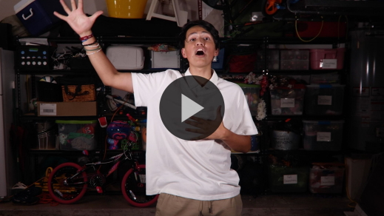

[Matthew 28:19](https://ref.ly/logosref/Bible.Mt28.19) (NLT)

“Therefore, go and make disciples of all the nations, baptizing them in the name of the Father and the Son and the Holy Spirit.”

Supporting missionaries with prayer and money is one way we can be part of God’s mission and share God’s love with others.

**Faith Fact**

Before we go to our small groups, let’s take a look at the Faith Fact one more time.

• *Show the* ***Faith Fact Slide****.*



Say it with me. **I will help others go.** God has a special job for all of us to do so the world can hear about Jesus. We can go, we can pray, and we can give. All three jobs help send missionaries into the work God has called them to do.

• *Dismiss kids to Small Group time or to go home if your group time ends here.*

**Small Group**

**30 Minutes**

*This section can be done in conjunction with the large group or on its own if you do small groups with your kids. During Small Group time, the goal is to connect the kids with the Word of God and to each other. All activities are led by the small group leader.*

**Group Connection**

**Team Cup Stack**

|  |
| --- |
| ***You Will Need***   * + *Paper or plastic cups, six per group*   + *Rubber bands, 2–3 inches in size, one per small group*   + *String or yarn, 24 inches long, one piece per kid*   + *Scissors*   + ***Countdown60 Video****–60 seconds*   ***Getting Ready***   * *Cut pieces of string about two feet in length, one piece per kid.* * *Optional: Watch this video to see how the activity works.* [*https://www.youtube.com/watch?v=jc_QNz_NbkM*](https://www.youtube.com/watch?v=jc_QNz_NbkM) |

We’ve been talking about how we can work together to help others. So let’s do an activity called Team Cup Stack. We’ll work together to stack the cups, but there’s one rule. No one can touch the cups. Sounds impossible, doesn’t it? *(Group response)*

We’re going to use a rubber band with strings tied on it to be a lifting contraption. The goal is to build the tallest cup tower possible in sixty seconds. You’re going to need a lot of teamwork and communication. Let’s build our lifting contraption!

• *Place one rubber band on the table.*

• *Give a piece of string to each kid. Instruct them to loop each of their strings through the rubber band and then tie the ends of their string together with a knot. Each kid will then have a string-loop handle connected to the rubber band.*

• *Place the cups in the center of the table and have the group gather around them.*

Now here’s the tricky part. Everyone will gently pull your string to stretch the rubber band and put it around a cup. Next you’ll ease up on your string to let the rubber band tighten around the cup. Then you’ll lift the cup into place together. Let’s practice.

• *Guide the kids to move one cup next to another cup. Keep practicing if needed until the group can move a cup together.*

Do you think you have it down? *(Group response)* Let’s see how many cups you can stack before time is up.

• *Start the* ***Countdown60 Video.***



• *Allow kids to work together to see what they can build in the time allowed.*

Wow, you did a great job working together! Was it hard to work together on this? *(Group response)* When everybody is helping, it can be challenging to get the result you have in mind. The answer is to communicate a lot and make sure everyone is able to help out and do their part, The same thing is true when we help missionaries. If we all do our part, we can do amazing things for God!

**Learn about It**

|  |
| --- |
| ***You Will Need***   * *Bibles for kids in your group to share*   *No prep is needed.* |

**Scripture Search:** [Luke 10:2](https://ref.ly/logosref/Bible.Lk10.2); [Acts 1:8](https://ref.ly/logosref/Bible.Ac1.8); [1 Corinthians 3:5–9](https://ref.ly/logosref/Bible.1Co3.5-9)

Let’s dig deeper into God’s Word and see what else He has to say about helping others fulfill God’s mission. As we find and read these verses, let’s ask ourself this question: What does this Scripture mean for our life today?

• *Give each kid a Bible and search for one or more of the Scriptures as a group together (as time allows). When everyone has found the Scripture, have one of the kids read it. Then answer the question about it: What does this Scripture mean for our life today?*

• *Pair kids who need additional help with older kids or start simple and look up the session’s Bible story scripture:* [*Acts 13:2–12*](https://ref.ly/logosref/Bible.Ac13.2-12)*;* [*2 Corinthians 8:1–5*](https://ref.ly/logosref/Bible.2Co8.1-5)*. Kids will get better at finding Scriptures the more they practice.*

• *Optional: Make this a competition to see who can find the Scripture first.*

**Bible Reading Tip**

There are lots of pages in the Bible! Sometimes there is a special verse you want to be able to find again, but you don’t know how. That’s why it’s important to know how to use the table of contents of your Bible. First, you’ll need to know the reference of the verse you want to find. A *reference* is the book name, chapter number, and verse number of a certain verse. (You can make a list of references to help you remember where to find your favorite verses.)

When you know the reference of the verse you want to find, look at the table of contents in the front of your Bible. Find the page number the book starts on, then turn to it. When you’re there, use the big numbers on the pages to find the right chapter and the smaller numbers to find the right verse.

**Challenge**

I want to challenge you to find one of the Bible verses we talked about today in your Bible at home sometime this week. If you need help, ask your parents. Remember to look for the book first, then the chapter number, and then the verse number.

**Faith Fact**

God’s Word is powerful, and God wants everyone in the world to be able to read it and learn more about Him. That reminds me of our Faith Fact. **I will help others go.** Say it with me as you march in place. **I will help others go.**

**Group Discussion**

*Feel free to use all or just a few questions as a jumping-off place for good discussion. Questions marked with * are designed for more conversation. Adjust the questions based on the age or maturity of your group. Typically, older kids will be able to dive a little deeper than younger ones.*

**Questions**

• *If small group activities are not immediately following large group time, you may want to read the Bible story passage before this discussion.*

If you could be the sidekick or buddy for the hero in any book or movie, who would you be?

* What are some questions you have about missionaries or what they do?

* What stood out to you most about today’s Bible story?

What did people do to help Barnabas and Saul on their missionary journey?

What are some ways we can fulfill God’s mission?

Why does God call people to go around the world?

Why is it important to support missionaries by praying?

Why is it important to support missionaries by giving?

* Would you like for God to choose you to be a missionary? Why or why not?

**Prayer Requests**

*Finish group discussion by sharing prayer requests and praise reports. Keep track of your small group’s prayer requests and review them each time you meet.*

**Prayer**

*Have kids pray for each other’s prayer requests.*

**Faith Verse Review**

|  |
| --- |
| ***You Will Need***   * *Cups, two per group* * ***Small Group Faith Verse Review Page****, two copies per group* * *Scissors*   ***Getting Ready***   * *Print copies of the* ***Small Group Faith Verse Review Page****, two per group* * *Cut apart each set and place each set of slips in a cup.* |

Our Faith Verse is [Matthew 28:19](https://ref.ly/logosref/Bible.Mt28.19). Just before Jesus went back to heaven, He explained to His followers God’s plan to tell the whole world about His love. Let’s take another look at what Jesus said.

• *Show* ***Faith Verse Video****.*



[Matthew 28:19](https://ref.ly/logosref/Bible.Mt28.19) (NLT)

“Therefore, go and make disciples of all the nations, baptizing them in the name of the Father and the Son and the Holy Spirit.”

God wants us to help make disciples in every country in the world. And we all have special jobs to make that happen! Let’s review our Faith Verse a few more times. Try to memorize it if you can so you’ll be ready for the Faith Verse game.

• *Say the verse as a group a couple of times.*

**Faith Verse Fun**

**Faith Verse Relay**

Now let’s play a game called Faith Verse Relay. Let’s form two teams and line up with your team. Each team will have a cup that’s full of words from the Faith Verse. One at a time, you’ll run down to your team’s cup and grab a word. Then run back to your team and tag the next person to get another word. While a teammate is collecting a slip, the rest of the team can work together to put the words of the verse in order on the floor. When you have all the words in the right order, say the verse together. The team that puts all the words in order and says the verse first wins!

• *Race to put the Faith Verse in order.*

Great job! Let’s keep this verse in our mind and heart. It will help us stay focused on fulfilling God’s mission of sharing His love and truth with the whole world.

**Activity Page**

**Color by Number**

|  |
| --- |
| ***You Will Need***   * ***Small Group Activity Page****, one per kid* * *Crayons or markers*   ***Getting Ready***   * *Print copies of the* ***Small Group Activity Page****, one per kid.* |

Today’s Activity Page has a color-by-number globe on it. Remember, God wants to use us to help send the gospel around the world. When we listen to God’s voice and obey His call, we fulfill His mission!

• *Give each kid a copy of the* ***Small Group Activity Page*** *and crayons or markers.*

**Dismissal**

God wants to use each one of us in a powerful and unique way so other people can hear the truth about Jesus. If you ever wonder what God wants *you* to do to help fulfill His mission, remember the three big jobs we talked about today. You can send others by praying. You can send others by giving. Or God may call you to become a missionary and take the gospel to another country yourself. Whatever God tells us to do, let’s be ready to say yes! Pray with me as we close today.

**Prayer**

|  |
| --- |
| *Dear God, please help us know the job You have for us to do. Maybe You want us to go. Maybe You want us to pray for missionaries. Or maybe You want us to give money to support missionaries. Give us the courage to say yes to Your call. Help us remember how important it is for the whole world to hear about Jesus. Amen.* |

**Faith Fact Recap**

• *Show the* ***Faith Fact Slide****.*



Something important to remember from today is our Faith Fact. Let’s say it together one more time. **I will help others go.** I’m so glad we got to learn this powerful truth together. I can’t wait to see you next time!

• *Send home the* ***Small Group*** ***Activity Page.***

• *Remind parents that there are* ***Family Devotions*** *available on the app to do with their kid.*

• *Tell everyone the date and time for the next session.*

.